TO: DR. RICK SCHUHMANN, LYDIA KARLHEIM
FROM: KEVIN FORGIE, SAMUEL BARBER, LINDSAY AUGUSTERFER, JONG-HUN
CHUNG
SUBJECT: JUDGMENT PAPER
DATE: MARCH 28, 2011
_____________________________________________________________________________________

Introduction:
The purpose of this memorandum is to answer key questions about scientific literature concerning global warming. To achieve this, the team has analyzed numerous relevant sources and come to consensus. The specific questions addressed are:
- Is all peer-reviewed literature reliable?
- Is there a scientific consensus regarding anthropogenic climate change?
- Did climate scientists, including Dr. Mann at PSU, engage in an unethical “trick” in order to hide an actual global trend in declining temperature?
- What perspective does retired US military leadership hold regarding climate change?
- What perspective does the current US military hold regarding climate change? From a practical perspective, why might the Navy be more concerned about climate change than the Army?
_____________________________________________________________________________________

1. Is all peer-reviewed literature reliable?
The main focus of this section is an article published in the Journal of American Physicians and Surgeons (JPandS) in 2007, entitled “Environmental Effects of Increased Atmospheric Carbon Dioxide.” This journal is the official publication of the American Association of American Physicians and Surgeons (AAPS), and was formerly known as the Medical Sentinel until 2003 (1). According to its mission statement, this publication “is committed to publishing scholarly articles in defense of the practice of private medicine…integrity in medical research…and challenging political correctness, dogmatism and orthodoxy with logical reasoning, valid data, and the scientific method (2).”
Initially, it was strange that an article on climate change would be published in a medical journal. JPandS claims, though, that all of its articles are subject to a double-blind peer review – so at first glance one would assume their material to be trustworthy (3). None of the JPandS articles can be found in major databases of scientific literature such as Medline/PubMed, Web of Science, and Compendex, though this may be due to the fact that it is an open access journal. However, JPandS has been involved in several scandals within the medical field. For example, it has published articles claiming things such as “‘humanists have conspired to replace the ‘creation religion of Jehovah’ with evolution,” “HIV does not cause AIDS,” and “the "gay male lifestyle" shortens life expectancy by 20 years (1).” Lastly, it has been subject to numerous criticisms from the scientific community, being called “speculative,” “right-wing propaganda,” “misinformed,” “arrogant,” and “ignorant” (4)(5). Even major health organizations such as the American Cancer Society and World Health Organization try to distance themselves from the AAPS (1).
In conclusion, the Journal of American Physicians and Surgeons does not appear to be a credible source of information – in its own area of medicine. Thus, an article published in it about climate change is on even more shaky ground. Regardless of if it were peer reviewed, it is unlikely that the medical doctors doing the review were qualified to analyze its geoscientific contents properly.
The article itself was written by Dr. Arthur Robinson (and others) from the Oregon Institute of Science and Medicine (OISM). This organization was founded in 1980, for the purpose of “research in subjects immediately applicable to increasing the quality, quantity, and length of human life. Research in the Institute's laboratories includes work in protein biochemistry, diagnostic medicine, nutrition, preventive medicine, and aging (6).” This again raises the question why an organization focused on medicine is concerning itself with global warming. An interesting discovery, though, was that Dr. Jane Orient is both the Executive Director AAPS and a prominent figure in OISM – which explains why the article was published in JPandS (7).
That aside, it is still important to analyze the OISM and Dr. Robinson’s article for their scientific credibility in general. “Environmental Effects of Increased Atmospheric Carbon Dioxide” was first circulated among the scientific community in 1999 and again in 2007 (after a slight revision), along with a petition opposing the Kyoto Protocol, stirring up much controversy. Its format was made to match that of the Proceedings of the National Academy of Sciences, in an attempt to appear published by the National Academy of Sciences. This was not the case, and its information was found to be equally fraudulent. Several thorough, lengthy rebuttals have been published discrediting nearly all of the article’s claims, most notably that of Dr. MacCracken (8)(9). Not much additional information about the OISM or Dr. Robinson is available. Therefore, it was concluded that the Oregon Institute of Science and Medicine is not a credible scientific organization.
An online technological website, Ars Technica, posted an article concerning climate change and peer-reviewed literature. Its main point was that peer-reviewing is an important first step towards legitimizing a scientific journal article, but the reviewers don’t always catch everything. Therefore an equally important consideration is the scientific community’s reaction to the article. If it is controversial it will get a lot of attention – therefore scientists will be likely to point out errors if there are any. This is exactly what happened in the examples given on Ars Technica, as well as Dr. Robinson’s article in JPandS.

2. Is there a scientific consensus regarding anthropogenic climate change?
There is a clear scientific consensus that Earth’s climate is being affected by human activity. According to the report of Naomi Oreskes, out of 928 abstracts related to the climate change issue, published in scientific journals between 1993 and 2003, none of the papers disagreed with the consensus position that there has been observed warming of the earth’s climate over the last 50 years. Additionally, none of them contradicted the conclusion that greenhouse gases are accumulating in Earth’s atmosphere as a result of human activities, and that most of the observed warming of the last 50 years is due to that increase in greenhouse gas concentrations (10).
Through the Web of Science search engine, our group was able to find 53,515 results under the key phrase “Climate Change”, 3,409 results under “Anthropogenic and Climate Change”, and 13,862 results under “Global Warming.” Using the same criteria as Orsekes, however, resulted in 11,260 articles – this is largely different than 928, and raises several questions. What happened to the rest of the articles? Did any of them disagree with the supposed unanimous consensus?
We also conducted research regarding the ratio of journals with peer-reviewed articles to those without, within the area of climate change. We chose one website, populartechnology.net, which insists it has over 850 articles (disagreeing with anthropogenic global warming) published in 238 peer-reviewed journals of climate change or global warming. However, after cross-referencing these journals with Web of Science scientific database, it was found that 71 out of 238 journals, or 29.8%, were determined to be non-peer-reviewed journals. Even if they were all peer-reviewed, the collection on this website only represents, at best, about 25% of literature available on this topic (compared with 3,409 articles in Web of Science under the topic “Anthropogenic and Climate Change). Therefore, populartechnology.net’s “evidence” disagreeing with the general consensus that anthropogenic global warming exists represents a small minority of the scientific community.

3. Did climate scientists, including Dr. Mann at PSU, engage in an unethical “trick” in
order to hide an actual global trend in declining temperature?
The word “trick” being used in the context of science is generally used in a manner to describe an idea or concept that makes science simpler. For example, in calculus, we do not memorize the trigonometric identities for our health; we memorize them because it makes solving integrals and derivatives that much more simple; scientists figured out these identities because it makes things easier to compute. There are many times in engineering when we look at concepts and think, “why do we even need to know this?” However, most of that seemingly useless knowledge is just a way for us to solve something more simply. We use the Laplace transform as a trick in order to simplify differential equations into linear operators; we also use assumptions as tricks. So many of the calculations we perform in our homework and on exams is based off of assumptions - without making assumptions we could not estimate or solve the problem. The “no-slip” condition is a perfect example, because it helps to estimate the way fluid flows over a solid surface, though we know it is not a perfect computation of the actual science. Boundary conditions and initial conditions provide the information we need to solve problems that model the real world, because it is nearly impossible to set up situations that mimic the conditions and the chaos that our environment contains. In an internet search, there is simply no mention of a nefarious or secret usage of science “tricks” that aim to hide or cover up what is really going on in the environment.
After reading “Myth vs. Fact Regarding the ‘Hockey Stick’” and “The CRU hack,” it becomes clear that the research and results Dr. Mann found have been taken out of context and not analyzed the correct way (11)(14). It seems to just be ridiculous claims brought on by McIntyre and McKitrick, who are a Canadian mathematician and economist, respectively. It does not seem as though there is a trend in declining global temperature that scientists are trying to hide with a trick. It is stated that:
“There is no evidence of any worldwide conspiracy, no mention of George Soros nefariously funding climate research, no grand plan to ‘get rid of the MWP,’ no admission that global warming is a hoax, no evidence of the falsifying of data, and no ‘marching orders’ from our socialist/communist/vegetarian overlords (15).”
The claims of McIntyre and McKitrick have now been further discredited in peer-reviewed scientific literature, specifically in a paper to appear in the American Meteorological Society journal. The paper also stated that, “Finally, the evidence for exceptional late 20th century warmth in the context of the period since AD 1400 (in warm, cold, and annual temperatures) is a robust conclusion with respect to all of the factors considered (14).”

In Michael E. Mann: A scientist in the crosshairs of climate-change denial, Mann described the campaign to discredit him following the theft of emails, including some he wrote, from servers at England's University of East Anglia in 2009. In 2006, a National Academy of Sciences report endorsed the soundness of the “hockey stick” graph, saying that the last 50 years of the twentieth century were clearly the hottest of the past 1,000 years. The data for Mann’s study showed a clear “hockey stick” shaped increase in global temperature (13).
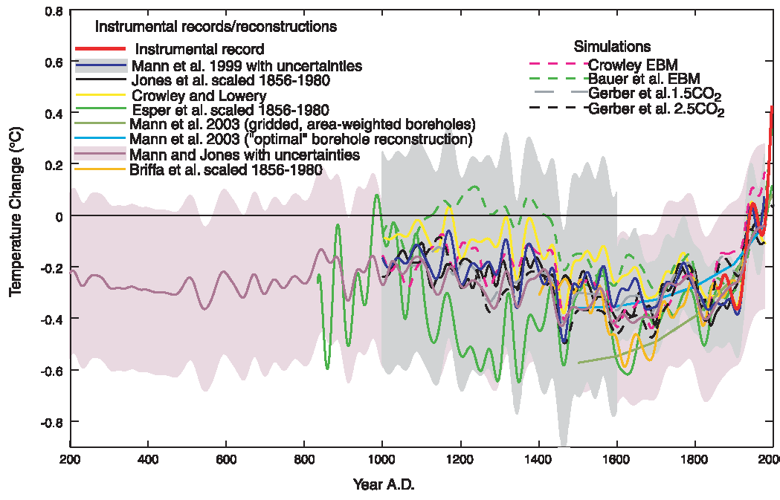
Figure 1 – Dr. Mann’s infamous “Hockey Stick” Graph
Climate-change denial groups said the emails showed unethical conduct, but scientific organizations and academic panels said this was not the case, defending Mann and the credibility of climate science. Mann believes the widespread media coverage contributed to the failure of the U.S. Senate to take action on carbon dioxide emission controls this summer. He cites polls showing that the matter may not have compromised public belief in climate science, and expresses positivity that policymakers will force emissions reductions in time to prevent truly catastrophic changes to Earth's climate. Scientific bodies including the American Association for the Advancement of Science, the American Meteorological Association, and the American Geophysical Union said the emails were misunderstood and the attacks unsubstantiated (12). Still, the broad media coverage clouded the judgment of the public, since the majority of people are not well-educated on climate conditions and global temperatures and may therefore draw ignorant conclusions.

4. What perspective does retired US military leadership hold regarding climate change?
In the National Security and the Threat of Climate Change report, the retired US military clearly views climate change as a serious problem that will directly affect the way the military is currently operating. They, however, take a bit of a different perspective on climate change than most people. Normally, climate change is seen as something bad for the earth and the environment in general. The military, on the other hand, is more concerned about how climate change will affect the way the United States functions. For example, the three questions this report set out to answer were: “what conditions are climate changes likely to produce around the world that would represent security risks to the United States? What are the ways in which these conditions may affect America’s National interests? And, what actions should the nations take to address the national security consequences of climate change (16)?” These questions are not the normal ones like, “What causes climate change?” and, “How can we fix it?”
Their findings from this report show that climate change poses a threat to America’s national security that they cannot overlook. In some places where the government is not particularly strong and life is marginal to begin with, climate change has the capability of adding problems to these areas. Extreme weather events such as drought, flooding, the spread of life-threatening disease, and many others will derive from climate change (16). These events will cause even more political instability in already volatile regions, and can lead to more failed states (16). They explain it like this, “When climate changes significantly or environmental conditions deteriorate to the point that necessary resources are not available, societies can become stressed, sometimes to the point of collapse (16).” America, being somewhat of a policing nation, sees this as a serious concern. Extreme environmental conditions will also have adverse effects on the military’s weapons, bases, and operations.
It is for these reasons that the US military believes it important to work toward limiting the amount of climate change. They stress that even though there is a general consensus among scientists about the changing climate, there is still uncertainty about the scope of this change. It is the military’s belief that action needs to be taken now. They will not wait for certainty on the issue because they do not make decisions in that manner. The military assess the possible risks to the US, and in their opinion, climate change poses a very serious risk.

5. What perspective does the current US military hold regarding climate change? From a
practical perspective, why might the Navy be more concerned about climate change
than the Army?
The current US military explained its perspective in the Quadrennial Defense Review. This report makes it clear that “the Department of Defense now considers climate change to be a legitimate national security concern (17).” They have legitimately integrated the problems posed by the changing climate into the QDR like no other strategy documents have before it (17). In this report they also discuss how evidence behind climate change is not certain. They do not know if it will even present a real threat when all is said and done. The DOD has expressed that much of this confusion stems from the fact that it is difficult to decipher what information is true and has been scientifically researched to what has been fabricated. In the end, though, it has been determined that “there is significant understanding to develop a realistic understanding of the risks (17).” However, the degree of concern that each branch of the military sees in climate change varies throughout.
The Army:
The Army and the Marines (ground forces), for example, have not contributed a great deal to the investigation of the changing climate’s effect on national security. Currently they are preoccupied with fighting two wars in Afghanistan and Iraq. Not to mention that they may soon be looking at a third in Libya. It is also likely that ground troops will see little change to the way they operate due to the effects of climate change. Conditions on the ground should remain similar to the way they are now.
The Navy:
The Navy on the other hand has made much more effort on this front. This makes sense because climate change is predicted to lead to rising sea levels, flooding, more severe storms, and other events that would greatly affect the way the Navy operates. The rising sea levels will add to and change the territory that they will need to manage. Flooding will require aid in not only developing countries, but as we saw from hurricane Katrina, the Unites States as well. Tropical storms will also add to the Navy’s workload. They will have to avoid these storms and also provide assistance when necessary. The Navy’s website explains that if sea levels rise only two meters, the Navy will most likely lose the ability to use some of their bases. They will also have to turn a lot of focus to the Arctic where conflict will likely occur with the melting of glaciers (18).

Works Cited:
- "Association of American Physicians and Surgeons." Wikipedia. Web. 26 Mar. 2011. <http://en.wikipedia.org/wiki/Association_of_American_Physicians_and_Surgeons>.
- "Medical Sentinel." Hacienda Publishing, Inc. Web. 26 Mar. 2011. <http://www.haciendapub.com/medsent.html>.
- "Journal of the American Physicians and Surgeons." AAPS - Association of American Physicians & Surgeons. Web. 26 Mar. 2011. <http://www.aapsonline.org/jpands/>.
- Seidel, Kathleen. "Strange Bedfellows." Web. 26 Mar. 2011. <http://neurodiversity.com/weblog/article/91/strange-bedfellows>.
- Gorski, David. "The Journal of American Physicians and Surgeons: Ideology Trumps Science-based Medicine." Science-Based Medicine. Web. 26 Mar. 2011. <http://www.sciencebasedmedicine.org/?p=99>.
- Oregon Institute of Science and Medicine. Web. 26 Mar. 2011. <http://www.oism.org/>.
- "Oregon Institute of Science and Medicine." Source Watch. Web. 26 Mar. 2011. <http://www.sourcewatch.org/index.php?title=Oregon_Institute_of_Science_and_Medicine>.
- "Oregon Institute of Science and Malarkey." Climate Science. Web. 26 Mar. 2011. <http://www.realclimate.org/index.php/archives/2007/10/oregon-institute-of-science-and-malarkey/>.Analysis by Michael MacCracken of the paper “Environmental Effects of Increased Atmospheric Carbon Dioxide” by Arthur B. Robinson, Noah E. Robinson, and Willie Soon
- MacCracken, Michael. Analysis by Michael MacCracken of the Paper “Environmental Effects of Increased Atmospheric Carbon Dioxide” by Arthur B. Robinson, Noah E. Robinson, and Willie Soon. Rep. 22 July 2008. Web. 26 Mar. 2011. <www.climatesciencewatch.org/file.../Comment_on_Robinson_et_al-2007R.pdf>.
- Oreskes, “Beyond the Ivory Tower, the Scientific Consensus on Climate Change”, Science, V 306, 2004.
- "The CRU Hack." RealClimate. 20 Nov. 2009. Web. 26 Mar. 2011. <http://www.realclimate.org/index.php/archives/2009/11/the-cru-hack/>.
- Mann, M.E., R.S. Bradley, and M.K. Hughes, “Northern Hemisphere Temperatures During the Past Millennium: Inferences, Uncertainties, and Limitations,” Geophysical Research Letters, 26, 759-762, 1999.
- "Michael E. Mann: A Scientist in the Crosshairs of Climate-change Denial." Bulletin of the Atomic Scientists. Nov.-Dec. 2010. Web. 26 Mar. 2011. <http://bos.sagepub.com/content/66/6/1.full>.
- "Myth vs. Fact Regarding the ‘Hockey Stick’" RealClimate. 4 Dec. 2004. Web. 26 Mar. 2011. <http://www.realclimate.org/index.php/archives/2004/12/myths-vs-fact-regarding-the-hockey-stick/>.
- Rutherford, S., Mann, M.E., Osborn, T.J., Bradley, R.S., Briffa, K.R., Hughes, M.K., Jones, P.D., Proxy-based Northern Hemisphere Surface Temperature Reconstructions: Sensitivity to Methodology, Predictor Network, Target Season and Target Domain, Journal of Climate, in press, 2004.
- United States Military. National Security and the Treat of Climate Change. Alexandria, Virginia: The CNA Corporation. 2007. Web.
- Parthemore, Christine, and Will Rogers. Promoting the Dialogue: Climate Change and the
Quadrennial Defense Review. Washington D.C.: 2010. Web.
- “Climate Change on Navy’s Radar.” Navy.mil. n.p. January 3, 2010. Web. March 26, 2011.

